GEOG.355 Bridgewater State University
POLITICAL GEOGRAPHY
Spring 2016 Instructor: Prof. V. Domingo
vdomingo@bridgew.edu
http://webhost.bridgew.edu/vdomingo

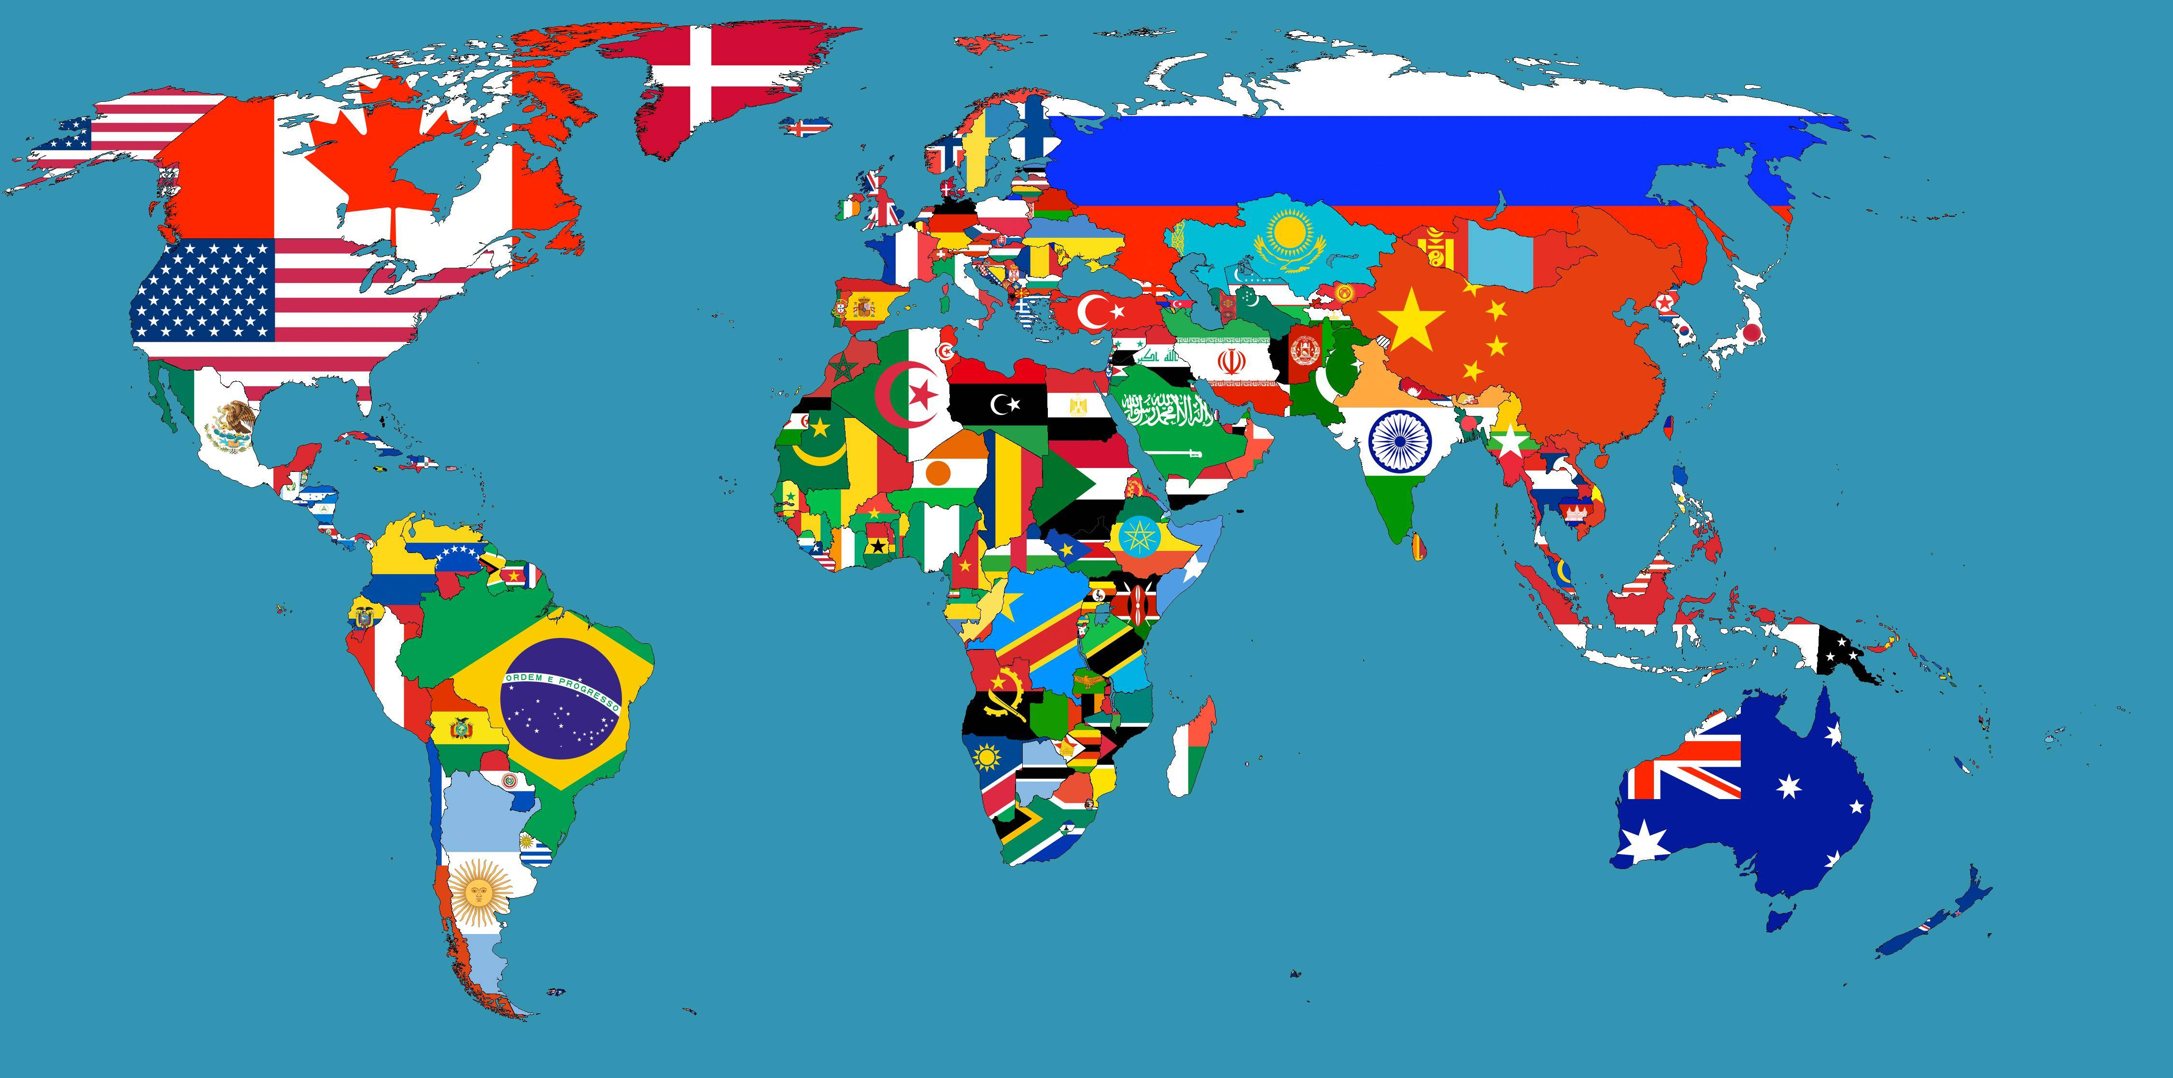

"A large proportion of the problems with which people are struggling in local, national, and international affairs are wrapped up in a package addressed to geographers."
Robert Platt

This course will explore to what extent the geographic perspective contributes in furthering our understanding of critical political issues of the day. Our concern here is with the interaction between politics and geographic phenomena (be they spatial, cultural, or environmental).

Some of the topics that this course will pursue:
Territoriality; The global political system; the state and beyond; nationalism and imperialism; ethnic conflict; boundary studies; How to lie with maps; Place and identity politics; The geography of inequality; Colonialism and imperialism; Regional conflicts; Electoral geography; The geography of indigenous peoples; Gender sexuality and space; The Law of the Sea; urban politics; the political geography of social movements; The geopolitics of minerals; Ecological perspectives.

The primary focus will be on contemporary events and you are expected to keep abreast of published reports in a variety of news sources. Among the sources that we will refer to regularly are: The New York Times, and the NPR program www.theworld.org
Text: Painter, Joe, and Jeffrey, Alex, Political Geography 2nd edition, Sage, 2009.

Articles handed out in class or sent on PDFs.

--------------------
Course requirements:

In-class discussion
Class assignments
2 class tests
Term Paper
Final exam

Calculation of final grade:

Class assignments  & discussion ..................... | 25%
Class tests ........................ | 30%
Term paper ...................... | 30%
Final exam ....................... | 15%

***************************************************



