Geographic Frameworks
Sarah Morse, Nick Boyle
Mapping the Essex!

Grade level: 2nd Grade

Goal: The goal of this lesson is to have students understand what a map is, how to make one, and how it relates of the Essex’s voyage.

Objectives: Have students label the countries involved in the book “In the Heart of the Sea.” Then label the map elements. (Title, scale, north arrow, make own legend, etc.). Have them construct their own paper boats. After that, have them mark out the actual route of the Essex voyage with their markers and the boats that they made.

Procedure: Ask students if they remember what a map is, what we use them for, and what type of maps there are. (In response to student’s answers the teacher should answer with, an image that gives locations and features, we use them every day to locate places and understand information that surrounds us, there are 2D maps, 3D maps, mental maps.) Pull down the pull-down map to review continents and bodies of water. Split up the class into several groups of two or three depending on class size. Hand out a poster board (the poster board is completed with a blank map of the world), labels, markers, tape, and boat paper to each group. Have them label each part of the map, both geographical and the map elements. After constructing their group maps, allow the students to make their own ships in a separate art activity. Once their ships are built, have them place them along the route of the Essex Whaling Ship. (The projection of the route will be on the board if they are unsure of the actual route.) Once they reach the last stop with their boats, then they can throw their boats in a bowl of water provided by us, to show the sinking of the ship).

Skills: Create and use a map of the world to track and get a better understanding of the route the Essex Ship took. This project creates hand on learning. Teaches bodies of water, map skills and meets the geography standards.

Geography Themes: Location, Regions, Human-Environment Interaction.

Geography Standards: 1, 4, 12,15

Materials: Map of the world. Poster board. Labels. (scale, north arrow, legend, countries, oceans, etc.) Glue/tape, scissors, markers, and ship making paper. Classroom globe, and a bowl of water per group.

Items you will need
http://i.imgur.com/um3zfiO.png = this is the link to the big world map
Atlantic Ocean
Atlantic Ocean
Atlantic Ocean
Atlantic Ocean
Pacific Ocean
Pacific Ocean
Pacific Ocean
Pacific Ocean
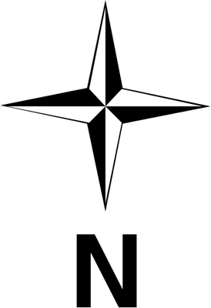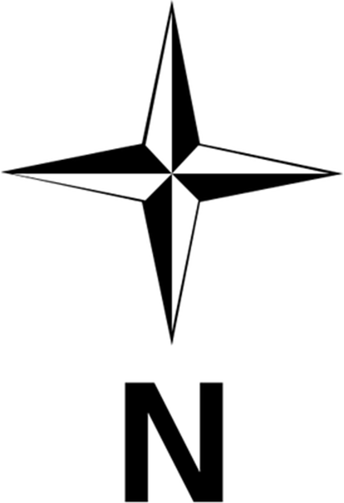
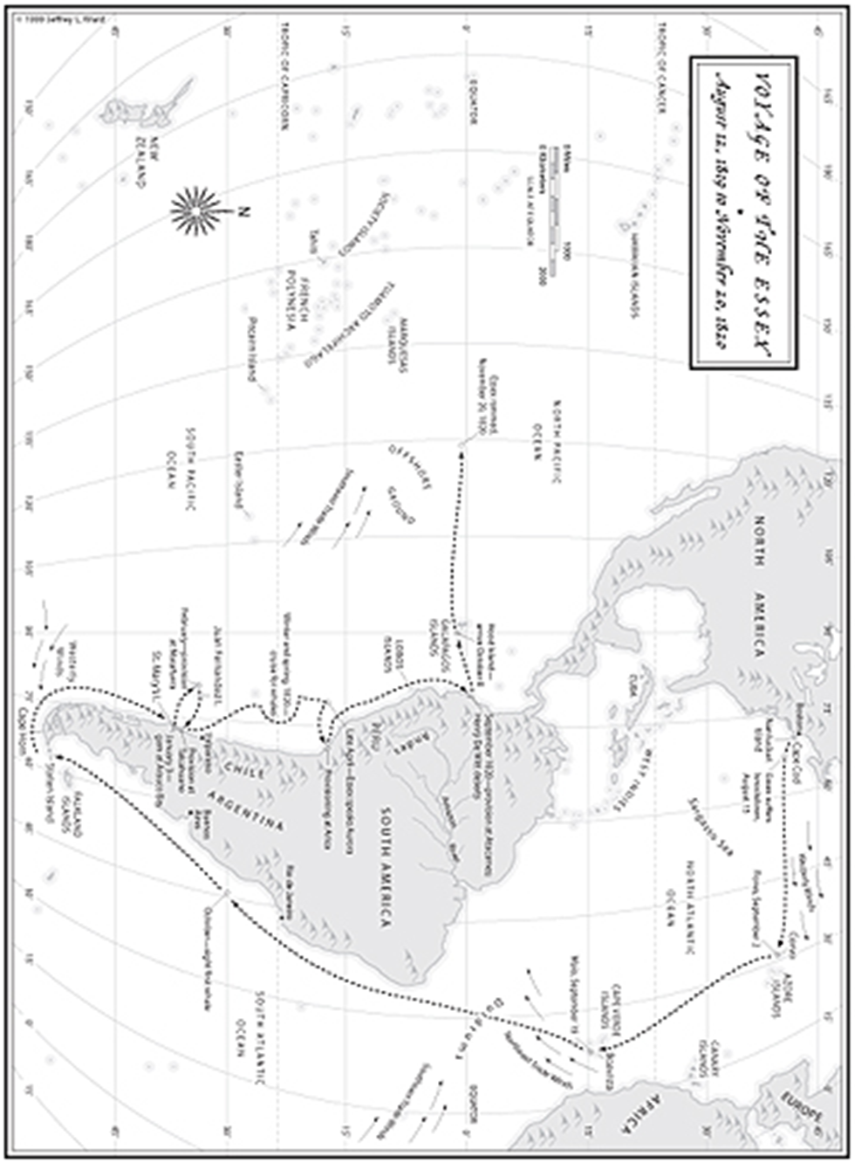
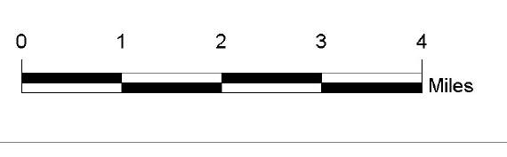
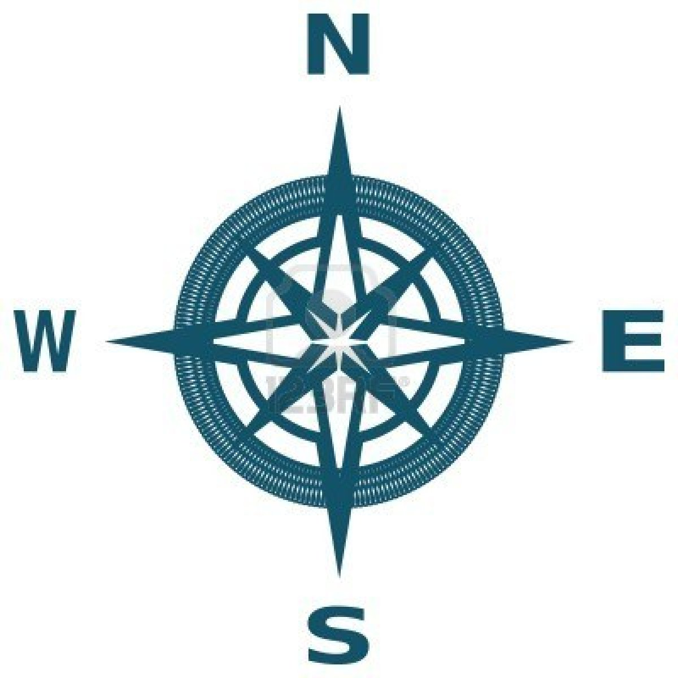North America
North America
North America
North America
South America
South America
South America
Europe
Europe
Europe
Europe
Asia
Asia
Asia
Asia
Africa
Africa
Africa
Africa
Australia
Australia
Australia
Australia
Antarctica
Antarctica
Antarctica
Antarctica
Indian Ocean
Indian Ocean
Indian Ocean
Indian Ocean
Arctic Ocean
Arctic Ocean
Arctic Ocean
Arctic Ocean
Antarctic Ocean
Antarctic Ocean
Antarctic Ocean
Antarctic Ocean

