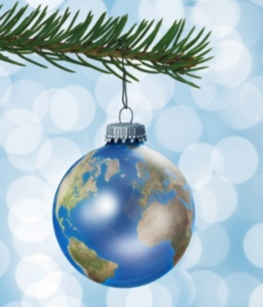
Earthly Ornaments
Grades 3 - 5

Goal:
This lesson was created to give students an opportunity to create an ornament of the Earth for them to give to their family. The ornament can be hung in their home year after year during the holiday season to be a symbol of “Peace on Earth” or “Joy to the World.” Having a mini globe on the Christmas tree or hanging elsewhere will remind the students the importance of learning geography and will encourage them to talk about geography with their family members. Students also will learn how Christmas and other holidays are celebrated differently throughout the world.

Objectives:
- To teach how holidays are celebrated differently in different countries.
- To reinforce the locations, shapes, and names of the continents.
- To emphasize the importance of knowing what the world looks like and learning geography.
- To provide an opportunity for students to be creative and artistic.

Skills:
The students are expected to:
- Learn how holidays are celebrated differently around the world.
- Think about how geography may affect why holidays are celebrated differently.
- Be creative and create their own unique globe ornament.
- Include islands on their globe and features such as ice, the equator, and a marking for where they live.

Geography Themes:
- Location- Students will think about the relative positions of the continents and oceans.
- Place- Students will think about the weather of different countries and what it is like during the holidays.
- Human-Environment Interaction- Students will learn how the environment impacts the way in which holidays are celebrated around the world.
- Movement- Students will see how ideas travel to different places and how different celebrations vary from place to place.
- Region- Students will see the cultural differences in how holidays are celebrated in different regions of the world.

Geography Standards:
- Standard 1- How to Use Maps and Other Geographic Representations, Tools, and Technologies to Acquire, Process, and Report Information From a Spatial Perspective
- Standard 2- How to Use Mental Maps to Organize Information About People, Places, and Environments in a Spatial Context
- Standard 10- The Characteristics, Distribution, and Complexity of Earth’s Cultural Mosaics

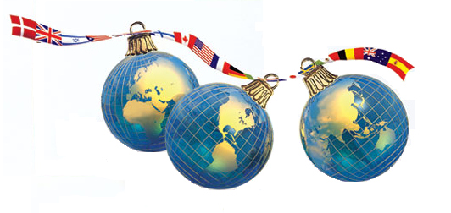

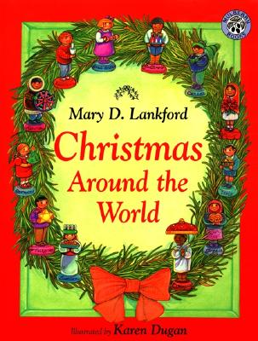
Materials:
- Book(s) about Christmas/Holidays around the world
- Globes
- Spherical plastic craft ornaments (can be different sizes)
- Pens
- Sharpies
- Scissors
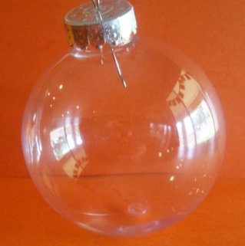
- Hole puncher
- Elmer’s Glue
- Scotch tape
- World map of appropriate size(s)
to create continent stencils
- Firm paper to create continent stencils
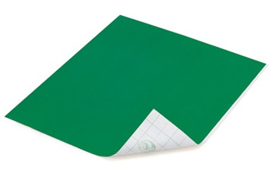
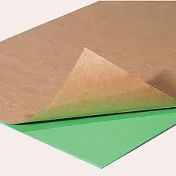
- Green “Duck Tape Sheets”
- Green “Peel & Stick Felt”
- White “Peel & Stick Felt”
- Green fabric paint
- White fabric paint
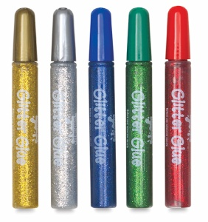
- Glitter glue (green, red, blue, silver, gold)
- Light blue paper crinkle
- Dark blue paper crinkle
- White paper crinkle
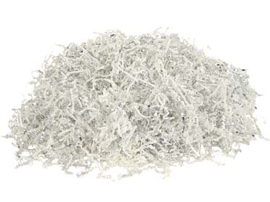
- Sequence
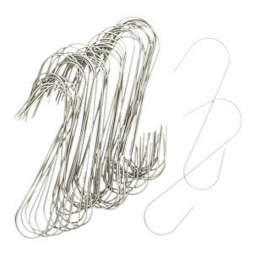
- Paper plates
- Wooden popsicle sticks
- Yarn or ribbon
- Ornament hooks

Introduction:
Introduce this lesson by talking about how there are different holidays in different parts of the world, and how even the same holidays are celebrated differently in different parts of the world. There are similarities and differences in how Christmas is celebrated from continent to continent, and even between countries. Share books about holidays celebrated around the world, such as Christmas Around the World by Mary D. Lankford. This book talks about how Christmas is celebrated in twelve different countries. It discusses the history and traditions of Christmas in those locations and also states the symbol and greeting of Christmas and what the weather is like there during this time. Explain how the most popular symbol for Christmas is the Christmas tree. Ornaments are put on the tree. Common phrases on ornaments are “Joy to the World” and “Peace on Earth.” Explain to the students that they will be making globe ornaments to symbolize these phrases and remind them how important it is to learn geography.

Procedure:
- Preparation: Have continent stencils made for each size ornament being used. Gather the materials needed and set up work spaces for the children. Use decorative paper plates for them to work on. Also have materials laid out on each table and have a popsicle stick at each work space.

- Have the students choose their ornament and remove the covers. Keep them aside to be replaced later.

- Decorate the inside of the ornament using white paper crinkle (poles) and blue paper crinkle (ocean). Use a popsicle stick to help stuff it into the ornament.
- Stuff the ornament with a thin layer of white paper crinkle.
- Stuff the ornament almost completely full with either dark blue or light blue paper crinkle.
- Stuff another layer of white paper crinkle onto the top.
- Replace the cover onto the ornament.

- Decorate the outside of the ornament using a variety of materials.
- Trace the appropriate size continent stencils onto either a green “Duck Tape Sheet” or on green “Peel & Stick Felt.” Antarctica can be traced onto white “Peel & Stick Felt.” Carefully cut out the continents.
- Peel the back off of the continents and place them onto the ornament in their respective locations.
- Use green and white fabric paint and assorted glitter glue to decorate the ornament.
- Ideas: Outline the continents with fabric paint, create islands, add Greenland with white paint, add the equator, glue a sequence where you live or in other meaningful locations, add blue glitter glue in the ocean, add green glitter glue on the continents, etc.

- Once decorating the ornament is completed, use yarn or ribbon to create a hanging hoop. Students can choose from an assortment of tags to hole punch and attach to their ribbon or yarn to give them as gifts to their family. Some examples of these tags are included. The tags can say “Peace on Earth,” “Joy to the world,” etc.

- For the ornaments to dry, tape the hoop to one end of a wooden popsicle stick. Tape the other end of the stick to the edge of a table where the ornaments can hang freely to dry for a few hours or overnight. Names can be written on the sticks. Ornament hooks can also be provided.

Evaluation:
This lesson plan is a fun geographic craft for the holiday season so it may not be necessary to have an evaluation. Having a completed globe ornament could be the evaluation in itself. Students could also be evaluated by having to fill in a blank map of the continents. Or, they could have to write about how Christmas or another holiday is celebrated in a different country. They could also write about how their own family celebrates the holiday.

