Name: __________________________ Date: _____________
Lab Section: ________________

CHEM 131 Lab Experiment: Molecular Structure Lab

Background
In this lab, we explore the chemical possibilities offered by carbon atoms which are the fundamental building blocks in organic and biochemistry.

Molecular Construction Kit (Eisco)
Color | Atom | Bonds (holes)
Black | Carbon (C) * | 4
White | Hydrogen (H) | 1
Red | Oxygen (O) | 2
Green | Chlorine (Cl) ** | 1
Blue | Nitrogen (N) | 3
Yellow | Sulfur (S) | 4,6
*There may be black spheres with two holes. Do not use them
**Green can be used for other halogen atoms; F, Br and I

Three types of "sticks" are provided:
  - Stubby one - do not use
  - Short straight - use this for a single bond
  - Long straight - use two of these for a double bond
Procedure
Part I — Look at the molecules listed on the attached sheet
Construct the six molecules in the Table and verify that the shape and the bond angles are correct (a protractor is attached for your convenience). Enter "check"
The double underlined atom is at the center
 | Shape | Bond Angle
CO₂
H₂CO (BF₃)
NOF (SO₂)
CH₄
H₂O

Part II- Carbon to carbon bonds
Project 2

Bonding of carbon and hydrogen. Since carbon has four holes and hydrogen has one, you can construct a molecule, CH4 (called methane, a major component of natural gas). You already did this in Part I
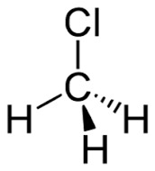
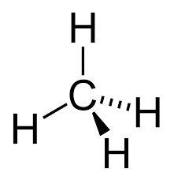

Methane (project 2) Chloromethane (project 3)
It is written on paper as a flat object, but in reality, it is a three-dimensional called tetrahedral. The angle formed by H — C — H is 109 °

Project 3

Just like hydrogen chlorine has one bond so you can substitute H by Cl, you can form CH₃Cl, chloromethane.
Even though on a paper, it may appear that there are four places that you can place chlorine, in reality all positions are identical, and you only have one CH₃Cl molecule.

Project 4

Now try to replace two hydrogens by two chlorine atoms. Now you form CH₂Cl₂, dichloromethane
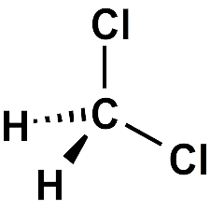

Again, on paper, it appears that you have two different molecules but in reality, you can see there is only one CH2CI2 .

Project 5

Carbon—carbon bond
Carbon atoms can bond together. Let's try connecting two carbon atoms
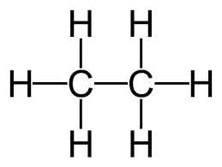
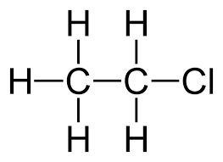

ethane (Project 5) chloroethane (project 6)
At this point, each carbon has three vacant spaces which will be used to connect hydrogen atoms. Now you formed a molecule called ethane, C2H6 .
Sometimes, it is written as CH₃--CH₃. The former is a molecular formula, while the latter a structural formula.
The bond between two carbons is made of one spring - called a single bond.

Project 6

If you substitute one hydrogen, you will form chloroethane, CH₃—CH₂Cl . There is one only compound for this formula.

Project 7

Now if you replace two hydrogens with chlorine, how many different compounds can you form?

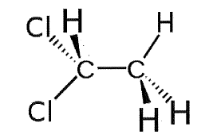
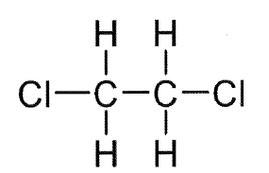

The answer is two - compare your model with others. They both have the same molecular formula, C2H4Cl2, but the structural formulas clearly show they are different, CH2CI — CH2CI and CH3 — CHCl2 . They are called isomers.

Project 8

Carbon-carbon bond
Now try connecting two carbon atoms using two springs, forming a double bond. When you fill the vacant spots with hydrogen, you form a molecule CH2 —— CH2, ethane.
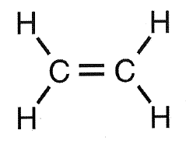
It is interesting to note that a double bond is rigid and non-rotatable. Also note that this molecule is a flat molecule.

Project 9

Now in CH2 = CH2, replace two hydrogens with chlorines. How many different molecules can be there?

Project 10

One of the most important organic molecules is benzene, C6H6 . Six carbons form a ring with alternating double and single bonds:
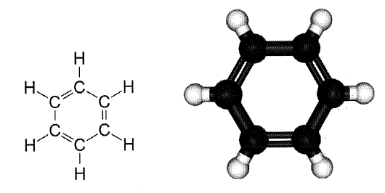

Part III — Function Groups
Project 11

A quick review is in order? Form water ( H2O), ammonia ( NH3), and methane (CH4). You did this in Part I

Project 12

From each of the above, remove one hydrogen atom. You will be left with a fragment of a molecule with one bond left unused. Compare this to chlorine atom which also has one bond . In chemistry, these are called functional groups and they can replace hydrogen. Function groups will determine the chemical properties of compounds.
Here are some common function groups:
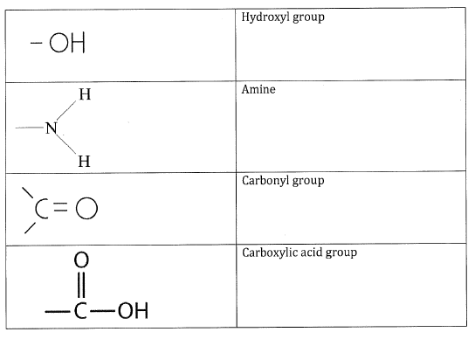
Construct CH₃OH (methanol) and C₂H₅OH (ethanol). These belong to a group of alcohol.
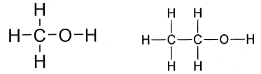
Project 13

Construct CH3NH2 (methylamine) and C2H5NH2 (ethylamine). These belong to a group of amine. The —NH2 end makes these molecules to act as a base, just like ammonia does.

Project 14
What about C₂H₅COOH (acetic acid)? The -COOH end makes this molecule to act as an acid.
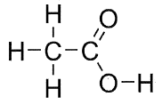

Project 15 Construct vinyl alcohol
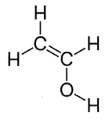

Project 16
Vinyl alcohol can be a polymer (you synthesized polymer during the first lab = Silly Putty and Gooey Gel). You can work with your benchmates

