Name: __________________________ Date: _____________
Lab Section: ________________

CHEM 131 Lab Experiment: Quantitative Determination of the Acid Content of Fruit Juices

Background
The sour taste of many fruit juices is due in large part to the presence of acids. Citric acid, C₃H₅O(COOH)₃ is one of several acids present in these juices. Citric acid reacts with sodium hydroxide (NaOH), a base, as shown in Equation 1.

C₃H₅ O(COOH)₃ + 3NaOH → C₃H₅O(COONa)₃ + 3H₂O (Eq. 1)
Sodium citrate
Equation 1 describes a neutralization reaction, in which an acid and a base react to form salt and water. Various acids are found in different amounts in different juices, but for the purpose of this experiment, we assume the acid is just citric acid.
We can determine the amount of acid in a given volume of fruit juice by titrating the juice with a standard NaOH solution. A standard solution is a solution of known concentration expressed usually in molarity.
The molarity (mol/ L, or M) of a solution is the number of moles of solute per liter of solution, as expressed by Equation 2.
molarity, M = ( number moles of solute) / volume of solution, L (Eq.2)
Titration is the measurement of the volume of a standard solution required to completely react with a measured volume or mass of the substance being analyzed. We add the standard solution from a calibrated glass tube called a buret. Before beginning the titration, we add an indicator to the titration mixture. An indicator is a substance that changes color at the point when the titration reaction is complete. In this experiment, you will use phenolphthalein as an indicator when you titrate fruit juice with NaOH solution. Phenolphthalein is a complex organic dye that is colorless in acidic solutions and pink in solutions that are slightly alkaline, or basic.
Sample calculation Assume that we want to determine the acidity C₃H₅O(COOH)₃ content of an orange juice sample. We find that 39.62 mL of 0.106 M NaOH solution are required to titrate a 10.0-mL sample of orange juice. We determine the number of moles of NaOH required to neutralize the C₃H₅ O(COOH)₃from the concentration and volume of NaOH solution used in the titration, and a rearrangement of Equation 2, shown as Equation 3. Note that in part of Equation 3 the NaOH volume is converted from milliliters to liters.
moles NaOH required
= (vol NaOH require, ml ) ( 1L/1000ml ) (conc NaOH sol, M ) =
= 39.62 ml (1L/1000ml) (0.106 mol NaOH / 1L sol ) =
= 4.20*10⁻³ mol NaOH ( Eq.3)

We determine the number of moles of C₃H₅ O(COOH)₃in the titrated juice sample using Equation 4 and the stoichiometry of the titration reaction given in Equation 1.
moles of C₃H₅ O(COOH)₃
= ( moles NaOH ) ( 1mol C₃H₅O(COOH)₃/ 3 mol NaOH )
= ( 4.20*10⁻³ mol NaOH ) ( 1 / 3 )
= 1.40*10⁻³ mol C₃H₅O(COOH)₃ ( Eq.4 )

We compute the mass of C₃H₅ O(COOH)₃ in the titrated juice sample using Equation 5. The molar mass of C₃H₅ O(COOH)₃ is 192.12 g/mol.
mass of C₃H₅ O(COOH)₃ in sample, g
= ( moles C₃H₅ O(COOH)₃ ) (192.12 g/mol / 1mol )
= ( 1.40*10⁻³ mol C₃H₅ O(COOH)₃ ) (192.12 g/mol / 1mol )
= 0.269 g C₃H₅ O(COOH)₃ ( Eq.5 )

For convenience in making comparisons between different juices, we determine the mass of C₃H₅ O(COOH)₃ present in 1ml of juice, using Eq. 6.
mass of C₃H₅ O(COOH)₃ in 1 ml juice, g/ml
= ( mass C₃H₅ O(COOH)₃ in sample, g ) / (vol juice titrated, ml)
= ( 0.269 g C₃H₅ O(COOH)₃ ) / (10 ml juice)
= 2.69*10⁻² g /ml C₃H₅ O(COOH)₃ (Eq.6 )

Remember that we assumed that the only acid present in the juice was C₃H₅ O(COOH)₃. This assumption is useful for comparative purposes.
In this experiment, you will determine the number of grams of acid, assuming it is entirely C₃H₅ O(COOH)₃, present in 1 mL of a fruit juice by titrating the juice sample with standard NaOH solution. If a variety of juice samples are available for analysis, you will be able to compare the acidities of these juices by comparing your results with those of your classmates.
Procedure
Preparing the Fruit Juice for Titration
Note: The numbers appearing in parentheses indicate the specific lines on your Data Sheet on which the indicated data should be entered.

1. Record the type of fruit juice and the code identification of the juice sample on your Data Sheet (1, 2).
Note: If the juice has substantial amounts of pulp floating in it, filter the juice by pouring it from the beaker into another clean, dry 100-mL beaker through some glass wool placed in a conical funnel. Otherwise, the pulp tends to obscure the titration end point.

2. Label two clean, 125-mL Erlenmeyer flasks “1” and “2.”
3. Measure 20.0 mL of your juice from the beaker into a 25-mL graduated cylinder. Transfer the juice into Erlenmeyer flask 1. Record on your Data Sheet the volume of juice transferred (3). Rinse the graduated cylinder twice, using 5 mL of distilled or deionized water each time. Transfer the rinses into Erlenmeyer flask 1.
4. Use the procedure in Step 3 to transfer a 20.0-mL juice sample to Erlenmeyer flask 2.
5. Add three drops of phenolphthalein indicator solution to the solution in each Erlenmeyer flask. Gently swirl each flask and its contents to thoroughly mix each solution.
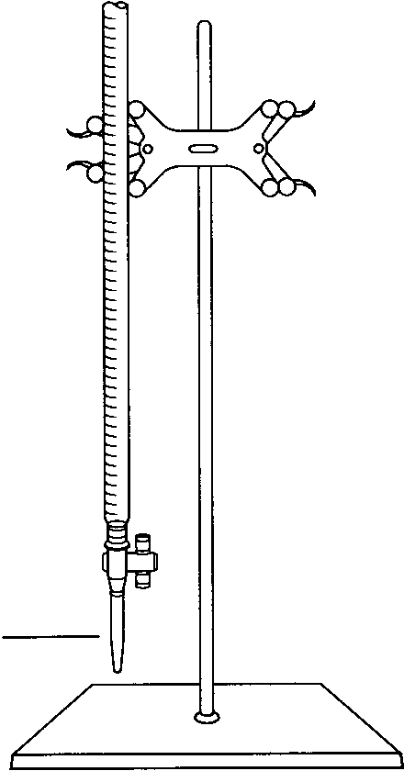
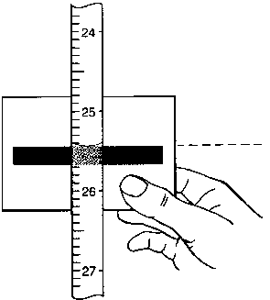
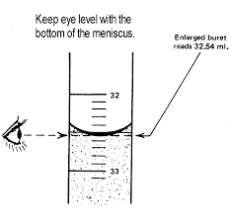

Figure 1 Titration apparatus Figure 2 Reading a buret
Titrating the Fruit Juice
Caution: NaOH solution is corrosive and toxic, and it can cause skin burns. Prevent contact with your eyes, skin, and clothing. Do not ingest the solution. If you spill any NaOH solution, immediately notify your laboratory instructor.

1. Obtain about 60 mL of standard NaOH solution in a clean, dry beaker. Record the exact molarity of the NaOH solution on your Data Sheet (4).
2. Rinse the buret with 5 mL of your standard NaOH solution. Hold the buret nearly horizontally. Rotate the buret so that the NaOH solution contacts the entire inner surface. Drain the solution through the buret tip into a waste beaker.
3. Clamp the buret to the support stand, as shown in Figure 1.
4. Rinse the inner surface of your short-stem funnel, using 5 mL of NaOH solution. Collect the rinse in your waste beaker. Place the funnel in the open top of your buret.
5. Close the stopcock. Fill the buret with NaOH solution to a level above the 0-mL calibration near the top of the buret. Remove the funnel from the buret and place it in a clean 150-mL beaker.
Note: Make sure that the buret tip is filled with NaOH solution. There should not be any air bubbles in the solution between the stopcock and tip or in the solution in the buret barrel.

6. Eliminate any air bubbles in the buret tip by carefully but rapidly rotating the stopcock a few times. Collect the small amount of drained NaOH solution in the waste beaker. Then, slowly drain NaOH solution into the beaker until the bottom of the meniscus is at the 0-mL calibration.
7. Lift the beaker and touch the buret tip with the wet inner side wall of the beaker above the solution surface to remove the drop of NaOH solution that may be clinging to the tip.
Note: A 50-mL buret is calibrated in units of 0.1 mL, but measurements to the nearest 0.02 mL can be reproducibly estimated. Estimate the liquid level if it is between calibration marks, and record every reading to the nearest 0.02 mL.

When reading the meniscus in the buret, you may find it helpful to hold a white card marked with a dark stripe directly behind and with the stripe slightly below the meniscus, as shown in Figure 2. Your line of sight must be level with the bottom of the meniscus.
8. Read the meniscus to the nearest 0.02 mL. Record this initial reading on your Data Sheet (6).

9. Place Erlenmeyer flask 1 under the buret tip. Lower the buret so that the tip extends about 3-4 cm into the mouth of the flask, as shown in Figure 3.
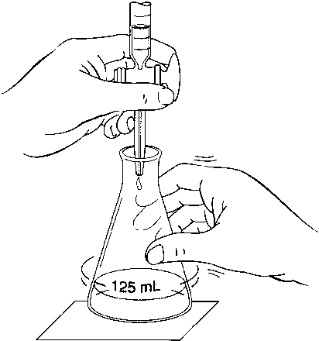

Figure 3 Positioning the buret for titration, and manipulating the stopcock
Note: If you are right-handed, gently swirl the flask with your right hand and control the stopcock with your left hand, as shown in Figure 3. If you are left-handed, swirl the flask with your left hand.

As the titration proceeds, you will observe a pink coloration at the point where NaOH solution contacts the juice solution. As you approach the end point of the titration, the pink will begin to momentarily flash through the entire solution. At this point, begin adding the NaOH solution dropwise.
Because of the color of the fruit juice, the end point may be difficult to observe. Consult your laboratory instructor if you encounter difficulty detecting the end point.
10. Add 1- to 2-mL volumes of NaOH solution at a time from the buret to the juice sample, while gently swirling the flask.
Note: Stop titrating when light pink persists throughout the solution for 30s after you have thoroughly swirled the flask. When this condition occurs, you have reached the end point.

11. Take a final buret reading after the titration is complete. Record this reading to the nearest 0.02 mL on your Data Sheet (5).
12. Refill the buret with your NaOH solution, following the procedure in Steps 5-7.
13. Titrate the juice sample in Erlenmeyer flask 2, using the procedure in Steps 8-11. Record your data under column 2 on your Data Sheet (3, 4, 5, 6).
Calculations
Do the calculations for each determination using equations 3-6 and the sample calculation given in the Background and record the results on your Data Sheet.

NAME: ___________________________ DATE: ______________
PARTNER: ________________________ SECTION: ___________
Fruit Juices
Data Sheet
Preparing the Fruit Juice for Titration
(1) Type of fruit juice
(2) Code identification of fruit juice sample (brand name)

 | Determination
 | 1 |  | 2
(3) Volume of fruit juice transferred |  | mL |  | mL
Titrating the Fruit Juice
(4) molarity of NaOH solution (M) |  | M |  | M
(5) final buret reading |  | mL |  | mL
(6) initial buret reading |  | mL |  | mL
volume of NaOH used |  | mL |  | mL
Treatment of Data ( for both determinations )
moles of NaOH required |  | mols |  | mols
moles of C₃H₅ O(COOH)₃ titrated |  | mols |  | mols
mass of C₃H₅ O(COOH)₃ in sample |  | g |  | g
mass of C₃H₅ O(COOH)₃ per mL of undiluted juice |  | g/mL |  | g/mL
mean mass of C₃H₅ O(COOH)₃ per mL of undiluted juice |  | g/mL |  | g/mL

Sample calculation:

NAME: ___________________________ DATE ______________
SECTION: ___________
Fruit Juices
Post-lab Questions
1) If available, compare your results with those of other class members who analyzed different juices. List the juices in order of increasing acidity.
type of juice g C₃H₅ O(COOH)₃ / ml

__________________ ________________

__________________ ________________

2) Briefly explain why it is essential that the beaker in which you obtain the standard NaOH solution be completely dry, while the flask into which you pour the measured juice sample need not be dry.

3) A procedural change in this experiment would be required if a student wanted to determine the acidity of tomato juice by titrating a juice sample with NaOH solution. Briefly explain.

4) Briefly explain why you would probably obtain inaccurate results if you used the titration data you collected in this experiment to calculate the actual percent of C₃H₅O(COOH)₃ in a juice sample.

5) Look in the Chapter Carboxylic acids and Esters in your textbook (or consult library, Internet ) and find:

The stinging sensation associated with red ant bites is due in part to ________ acid.
_______ acid gives vinegar its tartness. Rancid butter contains _________ acid.
_________ acid, found in valerian root has a strong odor.
The skin secretions of goats contain ____________ acid, which contributes to the odor associated with these animals.
Oxalic acid is present in ________, ________ and _________.
Glycolic acid is found in ______ ______ and ______ ________.
Lactic acid in found in _______ ________, _____________ and ________ ________.
The sharp taste of apples is due to ________ acid.
__________ acid is particularly abundant in grapes.

NAME:___________________________ DATE: ______________
SECTION: ___________
Fruit Juices
Pre-lab Assignment

1. Briefly explain why you should not drink any undiluted juice that has been brought into the laboratory.

2. Briefly explain the meaning of the following terms as they relate to this experiment.

(a) titration

(b) standard solution

(c) indicator

3. Briefly describe the procedure you should follow if your fruit juice sample contains excess pulp.

4. A student followed the procedure in this experiment to determine the number of grams of C₃H₅ O(COOH)₃ per 1 mL of an apple juice sample. The titration of 20.0 mL of the undiluted juice required 12.84 mL of 9.580 x 10⁻² M NaOH solution.
Find and show your calculations for:
- the number of moles of NaOH required for the titration.

(b) the number of moles of C₃H₅ O(COOH)₃ titrated.

(c) the mass of C₃H₅ O(COOH)₃ present in the juice sample.

(d) the mass of C₃H₅ O(COOH)₃ present in 1 mL of apple juice.

