**CHEM 132 Lab #9**

**Enzymes**

Adapted from: Timberlake, *Laboratory Manual for General, Organic, and Biological Chemistry*, Pearson, 3rd edition.

**Laboratory Goals**

* Prepare a solution of the enzyme amylase
* Describe the role of an enzyme as a catalyst in biological systems
* Set up chemical tests that measure the rate of an enzyme catalyzed reaction
* Observe the effects of enzyme concentration, temperature, pH, and inhibitors upon enzyme activity

**Background**

Biological reactions are catalyzed by enzymes that speed up chemical reactions operating at mild conditions of temperature and pH. As catalysts, enzymes lower the activation energy for chemical reactions, so less energy is required to convert the reactants to products. This decreased activation energy increases the rate of a biochemical reaction compared to the uncatalyzed reaction as shown in **Figure 1**.

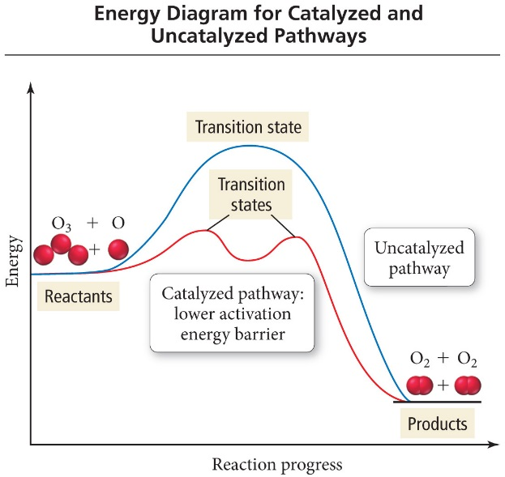

**Figure 1.** The catalyzed reaction pathway is lower in energy than the uncatalyzed reaction pathway.

**Testing Enzyme Activity**

In this experiment you will use a sample of amylase, an enzyme that catalyzes the hydrolysis of amylose. In the presence of amylase, a sample of starch will undergo hydrolysis to give smaller polysaccharides: dextrins, maltose, and glucose.



**Visual Color Reference**

As you proceed with each experiment, you will check enzyme activity by adding iodine to the starch mixture. When enzyme activity is high, the time required for the starch to be hydrolyzed will be very short. When the enzyme is slowed down or inactive, the blue-black color will be seen for a longer time. By observing the rate of disappearance of starch, you can assess the relative amount of enzyme using **Table 1**.

**Table 1.** Iodine test color and enzyme activity comparison table

|  |  |  |
| --- | --- | --- |
| **Iodine Test for Starch** | **Amount of Starch Remaining** | **Enzyme Activity** |
| Dark blue-black | All | 0 |
| Blue | Most | 1 |
| Light Brown | Some | 2 |
| Gold | None | 3 |

**Effect of Enzyme Concentration**

During catalysis an enzyme combines with the reactant or *substrate* of a reaction to give an *enzyme-substrate* complex. To form this complex, the substrate fits into the *active site*, where a reaction takes place. The *products* are released and the enzyme is ready to catalyze another reaction.



If the enzyme concentration is increased while substrate concentration is constant, the rate of the reaction will increase. With more enzyme present, more substrate molecules can react.

**Effect of Temperature**

The optimum temperature is the temperature at which an enzyme operates at maximum efficiency. At low temperatures, the rate of reaction is slowed. At high temperatures, enzyme protein is denatured. See **Figure 2** (next page) for more details.

**Effect of pH**

An enzyme is most active at its optimum pH. At pH values above and below optimum, the protein structure of enzyme is altered, which can severely reduce the enzyme’s activity. See **Figure 2** (next page) for more details.

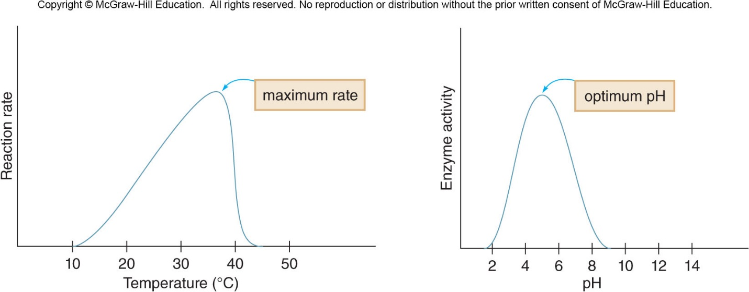

**Figure 2**. Enzymes attain their maximum rate (activity) at their temperature (left) and pH (right) optimums.

**Inhibition of Enzyme Activity**

Substances that limit or stop the catalyzing activity of an enzyme are called *inhibitors*. A *competitive inhibitor* competes for the active site of an enzyme, while a *non-competitive inhibitor* binds to the surface of the enzyme at another side and disrupts the structure of the active site. An *irreversible inhibitor* forms bonds with side chains of the amino acids in the active site, which makes the enzyme inactive, while a *reversible inhibitor* can dissociate from the enzyme and restore activity.



*Competitive Inhibitor*

*Non-Competitive Inhibitor*

**Figure 3.** Competitive inhibitors (left) compete with the substrate for the active site. When an inhibitor is bound it forms an *Enzyme-Inhibitor Complex* (EI). Non-competitive inhibitors do not compete with the substrate to for the active site and bind separately on the protein, changing the active site so product can be formed. This produces an *Enzyme-Substrate-Inhibitor Complex* (ESI).

**CHEM 132 Lab #9: Enzymes**

**Materials:**

Small test tubes, test tube rack, test tube holder, thermometer, 37 ºC water bath, hot plate, ice, several 250 or 400 mL beaker half full of water, droppers, well plate, 1% amylase solution. 1% starch solution (buffered pH 7.0), iodine reagent, 5 or 10 mL graduated cylinder, 1% AgNO3 solution, and 95% ethanol solution.

**Experimental Procedures:**

Make sure you are wearing **safety glasses at all times during this experiment**. Work in pairs.

**A) Effect of Enzyme Concentration**

Use the 37ºC water bath provided in the laboratory for the class for this experiment.

Add 5 mL of 1% starch solution in four separate test tubes labeled 1-4. Tube 1 without enzyme is the reference. Place the test tubes with 1% starch in the 37ºC water bath. After 5 min, add the following number of drops of amylase solution to the test tubes and mix.

|  |  |  |  |  |
| --- | --- | --- | --- | --- |
| **Reagent** | **Test Tube 1** | **Test Tube 2** | **Test Tube 3** | **Test Tube 4** |
| Starch | 5 mL | 5 mL | 5 mL | 5 mL |
| Amylase | 0 drops | 3 drops | 6 drops | 9 drops |

1. Immediately (0 min), using four separate droppers, transfer 5 drops of each reaction mixture in test tubes 1-4 to a well plate. Add 1 drop of iodine reagent to each solution. Record your observations.

Use the visual color reference chart (**Table 1**) to assess the enzyme activity.

Return the test tubes to the 37 ºC water bath.

1. After 5 minutes, test the samples again and record your observations.
2. After 10 minutes, test the samples again and record your observations.

**B) Effect of Temperature**

Prepare a boiling water bath with a 250 or 400 mL beaker about half full of tap water on a hot plate. Turn on heat and bring water to a boil (~100 ºC).

Prepare an ice water bath with a 250 or 400 mL beaker about half full of ice water and set it up with a thermometer on your bench. Check that the temperature of the water is 0-5 ºC.

*Prepare starch solutions:* Pour 5 mL of 1% starch solution into three different test tubes. Place one tube in your boiling water bath, one tube in the 37 ºC water bath, and one tube in your ice water bath. Allow the test tubes to remain in the water baths for 5 minutes to allow the solutions to reach the bath temperature. While these test tubes are reaching the experimental temperature, prepare the amylase solutions.

*Prepare amylase solutions:* Pour 1 mL of amylase solution into each of three other test tubes. Place one tube in a boiling water bath, one tube in a 37 ºC water bath, and one tube in an ice bath. Allow the test tubes to remain in the water baths for about 5 minutes to allow the solutions to reach the bath temperature.

*Mix starch and amylase solutions:* Remove the test tubes from the hot water bath and pour the 5 mL of starch into the test tube containing the amylase. Mix by shaking. Return the test tube to the hot water bath. Wait 5 minutes.

Remove the test tubes from the 37ºC water bath and pour the 5 mL of starch into the test tube containing the amylase. Mix by shaking. Return the test tube to the 37ºC water bath. Wait 5 minutes.

Remove the test tubes from the ice water bath and pour the 5 mL of starch into the test tube containing the amylase. Mix by shaking. Return the test tube to the ice water bath. Wait 5 minutes.

|  |  |  |  |
| --- | --- | --- | --- |
| **Reagent** | **Test Tube 1** | **Test Tube 2** | **Test Tube 3** |
| 1% starch | 5 mL | 5 mL | 5 mL |
| Temperature | 0 ºC | 37 ºC | 100 ºC |
| Amylase | 1 mL | 1 mL | 1 mL |

*Testing for Enzyme Activity:*

1. Transfer 4 drops of the mixture from the boiling water bath to a well plate. Add 1 drop iodine. Record the color and assess the enzyme activity.
2. Transfer 4 drops of the mixture from the 37 ºC water bath to a well plate. Add 1 drop iodine. Record the color and assess the enzyme activity.
3. Transfer 4 drops of the mixture from the ice water bath to a well plate. Add 1 drop iodine. Record the color and assess the enzyme activity.

**C) Effect of pH**

Pour 5 mL of 1% starch solution into four test tubes. Place the test tubes in the 37 ºC water bath. Wait 5 minutes.

Pour 4 mL of buffer solutions of pH 2, 4, 7, 10 into four other test tubes. Then add to each one of these test tubes 1 ml (or 20 drops) amylase. Place the test tubes in 37 ºC water bath. Wait 5 minutes.

After 5 minutes, pour each of the 1% starch solutions into each of the pH buffer-amylase tubes. Mix by shaking and return the mixtures to the 37 ºC water bath. Wait 5 minutes.

|  |  |  |  |  |
| --- | --- | --- | --- | --- |
| Reagent | Test Tube 1 | Test Tube 2 | Test Tube 3 | Test Tube 4 |
| 1% starch | 5 mL | 5 mL | 5 mL | 5 mL |
| Buffer solution | 4 mL of pH 2 | 4 mL of pH 4 | 4 mL of pH 7 | 4 mL of pH 10 |
| Amylase | 1 mL | 1 mL | 1 mL | 1 mL |

*Testing for Enzyme Activity*

Remove 5 drops from each of the pH 2, 4, 7, and 10 test tubes and place in a well plate. Add 1 drop the iodine reagent. Record your observations and assess the enzyme activity.

**D) Inhibition of Enzyme Activity**

Place 5 mL of 1% starch into three test tubes.

Place 1 mL of amylase into three other test tubes (test tubes 1-3 below).

* To test tube 1, add 10 drops of water (reference).
* To test tube 2, add 10 drops of AgNO3.
* To test tube 3, add 10 drops of 95% ethanol.

Place all six tubes in the 37 ºC water bath. Wait 5 minutes. After 5 minutes pour each of the 1% starch solutions into each of the inhibitor-amylase tubes. Mix by shaking and return the mixtures to the 37 ºC water bath. Wait 5 minutes.

|  |  |  |  |
| --- | --- | --- | --- |
| **Reagent** | **Test Tube 1** | **Test Tube 2** | **Test Tube 3** |
| 1% starch | 5 mL | 5 mL | 5 mL |
| Inhibitor | 10 drops water | 10 drops 1% AgNO3 | 10 drops 95% ethanol |
| Amylase | 1 mL | 1 mL | 1 mL |

*Testing for Enzyme Activity*

Remove 5 drops from each of your test tubes and place in a well plate. Add 1 drop of iodine reagent. Record your observations and assess the enzyme activity.

**CHEM 132 Lab #9 – Enzymes**

**Data Sheet**

**A) Effect of Enzyme Concentration**

|  |  |  |  |  |  |
| --- | --- | --- | --- | --- | --- |
| **Time** | **Observations** | **Test Tube 1** | **Test Tube 2** | **Test Tube 3** | **Test Tube 4** |
|  |  | No amylase | 3 drops amylase | 6 drops amylase | 9 drops amylase |
| **0 min** | Color |  |  |  |  |
|  | Activity |  |  |  |  |
| **5 min** | Color |  |  |  |  |
|  | Activity |  |  |  |  |
| **10 min** | Color |  |  |  |  |
|  | Activity |  |  |  |  |

At which enzyme concentration was starch hydrolyzed the fastest? Explain.

At which enzyme concentration was starch hydrolyzed the slowest? Explain.

**B) Effect of Temperature**

|  |  |  |  |  |  |
| --- | --- | --- | --- | --- | --- |
| **Tube 1 – 0 ºC** | | **Tube 2 – 37 ºC** | | **Tube 3 – 100 ºC** | |
| Color | Activity | Color | Activity | Color | Activity |
|  |  |  |  |  |  |

What was the optimal temperature for amylase activity?

**C) Effect of pH**

|  |  |  |  |  |  |  |  |
| --- | --- | --- | --- | --- | --- | --- | --- |
| **pH 2** | | **pH 4** | | **pH 7** | | **pH 10** | |
| Color | Activity | Color | Activity | Color | Activity | Color | Activity |
|  |  |  |  |  |  |  |  |

How is amylase activity affected by a low pH? Explain.

How is amylase activity affected by a high pH? Explain.

What was the optimum pH for amylase?

**D) Inhibition of Enzyme Activity**

|  |  |  |  |  |  |
| --- | --- | --- | --- | --- | --- |
| **Tube 1 – Water** | | **Tube 2 – AgNO3** | | **Tube 3 – Ethanol** | |
| Color | Activity | Color | Activity | Color | Activity |
|  |  |  |  |  |  |

In which reaction mixture(s) did hydrolysis of starch occur?

What substances added to the mixtures were inhibitors?

**CHEM 132 Lab #9 – Enzymes**

**Post-Lab Questions**

1. Describe the effect of enzyme concentration on enzyme activity.
2. Why would the enzyme activity of a sample at 0ºC differ from the enzyme activity of a sample at 37ºC? Why would the enzyme activity of sample at 37ºC differ from the enzyme activity of a sample at 100 ºC? Explain.
3. During digestion, the pH in the stomach is 2. What does this indicate about the optimum pH of pepsin, an enzyme that hydrolyzes protein in the stomach?
4. What happens to the activity of pepsin when it enters the small intestine where the pH is 8?
5. What are some differences and/or similarities in the type of inhibition caused by heat, acid or base, heavy metal ions, and ethanol on enzyme activity?

**CHEM 132 Lab #9 – Enzymes**

**Pre-Lab Assignment**

1. What is the substrate of the enzyme amylase?
2. What are the products of the amylase action?
3. What happens to enzymes at high temperatures?
4. What happens to an enzyme when a competitive inhibitor binds to it?