CHEM 132 Lab #7

Electrophoresis of Proteins

Introduction

Electrophoresis of macromolecules is one of the most common methods for the analysis of these molecules. Electrophoresis means movement (phoresis) in an electric field (electro). Complex mixtures of either proteins or nucleic acids (RNA or DNA) can be separated by electrophoresis. This experiment will demonstrate the most commonly used method for separating proteins, SDSPAGE [polyacrylamide gel electrophoresis (PAGE) in the presence of sodium dodecylsulfate (SDS)].

SDS is an anionic, amphipathic protein denaturant. When added to a solution of protein, SDS binds to and denatures proteins. To a first approximation, proteins in the presence of SDS adopt an elongated rod shape and have a negative charge that is roughly proportional to their length (or mass).

Polyacrylamide “gels” are commonly used as a support for electrophoresis. It is useful to think of these gels as a meshwork of filamentous polymer molecules, with much open space between different molecules (see Figure 1.) Varying the length of the polymer molecules (or operationally, the concentration of acrylamide used in the polymerization reaction) and/or the amount of crosslinking between the mostly linear polyacrylamide molecules results in gels with differing properties (see Figure 1).

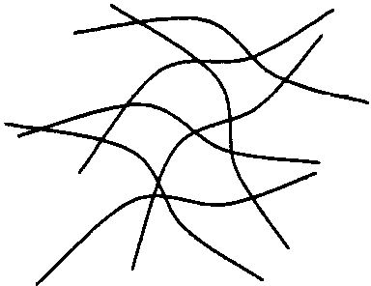

Figure 1. A schematic representation of a “low percentage” (left) and “high percentage” (right) polyacrylamide gel.

Gels prepared with a low concentration of acrylamide or with little crosslinking are more porous (i.e. they have larger and more pores or “holes” between the polymer molecules) than gels prepared with higher concentrations or more crosslinking.

When a SDS-protein complex is placed in a polyacrylamide gel and an electric field is applied to the gel, the protein will migrate (move towards) the positive pole (anode). The rate at which any particular protein moves depends on how fast it can wend its way through the pores in the polyacrylamide gel. The larger the protein, the more difficulty the protein has moving through the gel and the slower the protein migrates. Thus, proteins are separated by size with the smallest proteins moving the farthest into the gel and the largest staying near the origin.
The apparent molecular weight of unknown proteins is determined by comparing their mobility with the mobility of proteins of known molecular weight. The molecular weights obtained by SDS-PAGE are only apparent since the binding of SDS and the conformation of proteins denatured by SDS are not necessarily constant (as we assume). This fact sometimes leads to proteins running anomalously (i.e. any particular protein may migrate slower or faster than a standard with the same molecular weight). Thus molecular weights determined by SDS-PAGE must be considered “apparent” and approximate.

In order to determine the apparent molecular weight of an unknown, one runs a mixture of standard proteins in parallel with the unknown standards. By plotting the log of the molecular weight of the standards vs. the distance they migrated during the experiment, one obtains a linear standard curve that is used to determine the molecular weight of unknown proteins (see Figure 2).
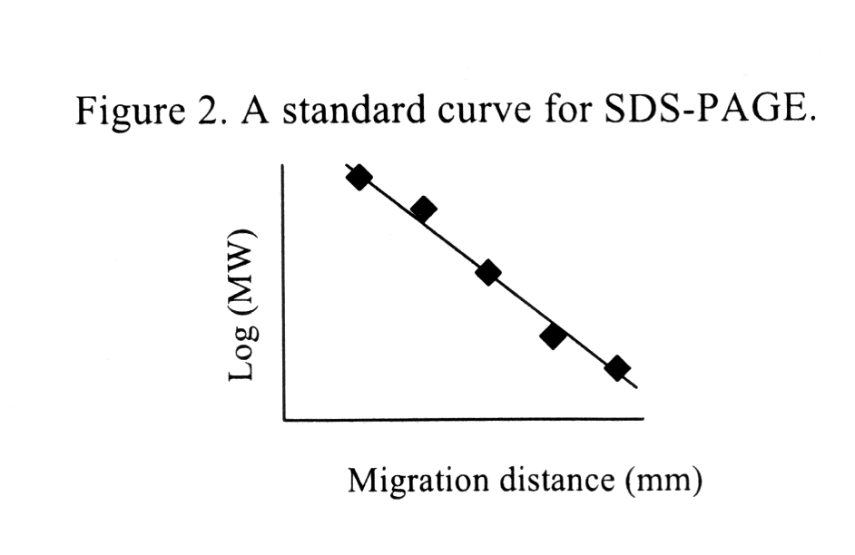

Today, you will learn to “run a gel”, to visualize the proteins in the gel by staining and to determine the apparent molecular weight of proteins.

Materials

Stock Solutions & Materials:

- Running Buffer (0.25 M Tris, 3.92 M glycine, 1% w/v SDS, pH 8.3)
- Staining solution (0.05% w/v Coomassie Blue R in 25% v/v iso-propanol, 10% v/v acetic acid)
- Destaining Solution (10% v/v iso-propanol, 10% v/v acetic acid)
- EZ-Run™ Protein Marker molecular weight protein standards:
- “unknown” protein samples
- Pre-made 10% polyacrylamide gel, 25mM Tris pH 8.3, 192mM Glycine, 0.1% SDS

Procedures

Gel Preparation - (pre-made 10% polyacrylamide gel, 25mM Tris pH 8.3, 192mM Glycine, 0.1% SDS)

- Remove the comb from the gel & straighten the well dividers if needed. Cut and remove seal from the bottom of the gel.
- Fit the gel into its chamber and then into the running “box”. Add running buffer to the appropriate chambers.
- Load samples onto the gel. There are six possible “unknown” proteins for you to choose from. You will choose three of the six. Be sure to record the unknown identifier.
  - Each group will load each of the samples (one standard and three samples) on to half on a gel.
  - Load 20 µl of each sample and 10 µl of the standards.
4) Connect gel to the power supply and run at 150 V until the tracking dye reaches the bottom of the gel.
5) Disconnect the gel from the power supply and remove the gel from the apparatus.

Staining & Destaining Gel

1) Place Gel in Tupperware container and cover gel with Coomassie Blue staining solution. Microwave the container for 20 seconds with the lid slightly open.
2) Discard staining solution into appropriate container & replace with 100 mL of destaining solution. Agitate and change the solution periodically until gel is destained (6-12 hours).

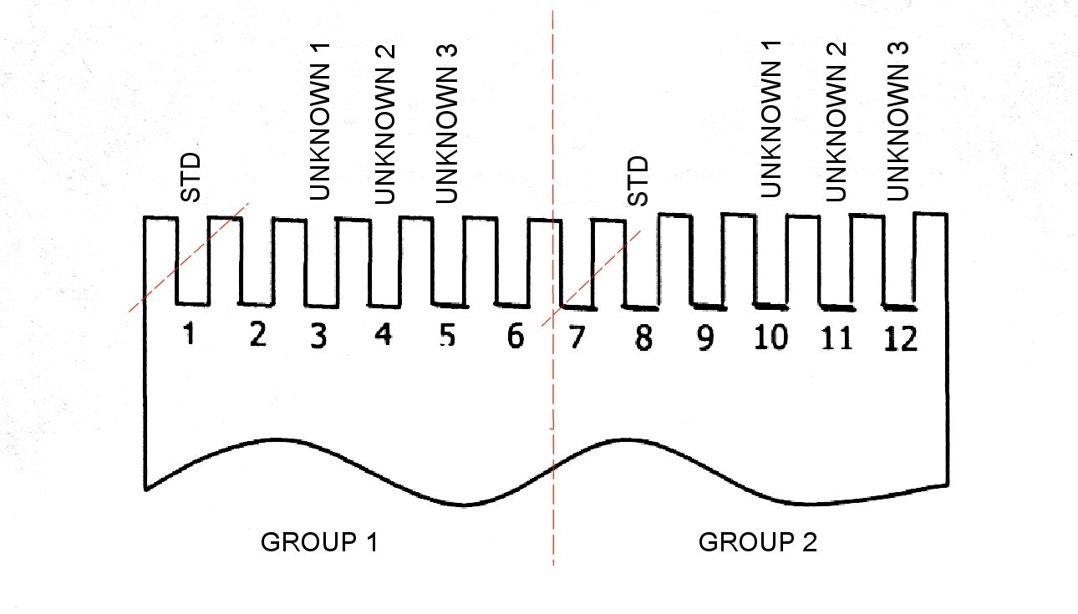
Gel

Determining the Apparent Molecular Weight of Unknowns

1) Take a picture of gel and print.
2) Measure the migration distance of the standard proteins and the unknown protein(s).
3) Plot the log (MW) of the standard vs. their migration distance.
4) Use this “standard curve” to find the MW of the unknown protein(s)
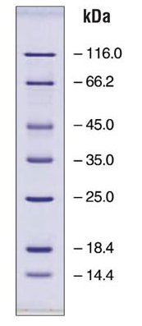
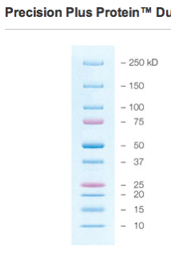
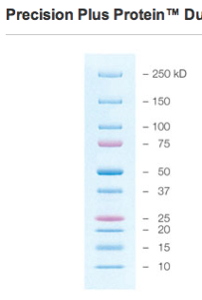
EZ-Run™ Protein Marker molecular weight protein standards
Standard Protein | Source | Molecular weight, kDa
ß-galactosidase | E.coli | 116.0
Bovine serum albumin | Bovine plasma | 66.2
Ovalbumin | Chicken egg white | 45.0
Lactate dehydrogenase | Porcine muscle | 35.0
Restriction endonuclease Bsp981 | E.coli | 25.0
ß-lactoglobulin | Bovine milk | 18.4
Lysozyme | Chicken egg white | 14.4

Data Sheet: Electrophoresis of Proteins

1. Fill in the tables:

Standard proteins | MW (kDa) | Log MW | Migration distance (mm)

Unknown # | Unknown identification | MW (kDa) | Log MW | Migration distance  (mm)

2. Create the standard curve by plotting in Excel, log of MW for the standard proteins vs their migration distance. Attach it to the Data Sheet.

3. Use this “standard curve” to find the MW of the unknown proteins.

4. Identify your unknowns based on the following information:

List of potential proteins used for unknowns
Protein | kDa
Ribonuclease A | 13.7
Lysozyme | 14.3
Myoglobin | 16.9
Trypsin | 23.3
chymotrypsin | 25
Lipase | 29
Lactic dehydrogenase | 35
Peroxidase | 37
Cellulase | 42
Bovine Serum Albumin | 66.5
Pyruvate Kinase | 237

Pre-lab: Electrophoresis of Proteins

1. Define:

- Amphipathic

- Denaturant

2. Describe the role of polyacrylamide gel in the process of electrophoresis.

