CHEM 132 Lab #4

Soaps & Detergents
Background
- Saponification: Preparation of Soap
For centuries, soaps have been made from animal fats and lye (NaOH), which was obtained by pouring water through wood ashes. The hydrolysis of a fat or oil by a base such as NaOH is called saponification and the salts of the fatty acids obtained are called soaps. The other product of hydrolysis is glycerol, which is soluble in water.
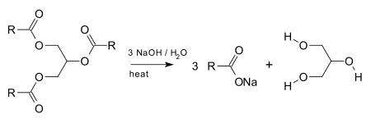
The fats that are most commonly used to make soap are lard and tallow from animal fat and coconut, palm, and olive oils from vegetables. Castile soap is made from olive oil. Soaps that float have air pockets. Soft soaps are made with KOH instead of NaOH to give potassium salts.
- Properties of Soaps and Detergents
A soap molecule has a dual nature. The nonpolar carbon chain is hydrophobic and attracted to non- polar substances such as grease. The polar head of the carboxylate salt is hydrophilic and attracted to water.

The dual polarity of a soap (salt of a fatty acid)

When soap is added to a greasy substance, the hydrophobic tails are embedded in the non-polar fats and oils. However, the polar heads are attracted to the polar water molecules. Clusters of soap particles called micelles form with the nonpolar oil droplet in the center surrounded by many polar heads that extend into the water. Eventually all of the greasy substance forms micelles, which can be washed away with water. In hard water, the carboxylate ends of soap react with Ca²⁺, Fe³⁺, or Mg²⁺ ions and form an insoluble substance, which we see as a gray line in the bathtub or sink. Tests will be done with the soap you prepare to measure its pH, its ability to form suds in soft and hard water, and its reaction with oils.
Detergents or "syndets" are called synthetic cleaning agents because they are not derived from naturally occurring fats or oils. They are popular because they do not form insoluble salts with ions, which means they work in hard water as well as in soft water. A typical detergent is sodium lauryl sulfate.
CH₃(CH₂)₁₀CH₂-SO₄⁻Na⁺ Lauryl sulfate salt, a biodegradable detergent
As detergents replaced soaps for cleaning, it was found that some of them ( branched alkyl sulfonates ) were not degraded in sewage treatment plants. Large amounts of foam appeared in streams and lakes that became polluted with detergents. Biodegradable detergents such as a linear alkylbenzenesulfonate detergent eventually replaced the nonbiodegradable detergents (branched alkyl sulfonates).

CH₃(CH₂)₉-CH(CH₃)-C₆H₄-SO₃⁻Na⁺ Laurylbenzenesulfonate salt, a biodegradable detergent
In addition to the sulfonate salts, a box of detergent contains phosphate compounds along with brighteners and perfumes. However, phosphates accelerate the growth of algae in lakes and cause a decrease in the dissolved oxygen in the water ( eutrophication ). As a result, the lake decays. Some replacements for phosphates have been made.
Objective
Prepare soap by the saponification of a fat or oil.
Observe the reactions of soap and detergent with oil, CaCl₂, MgCl₂ and FeC1₃
Materials
150-mL beaker, hot plate, graduated cylinder, stirring rod or stirring hot plate with stirring bar, large watch glass, 400-mL beaker, Buchner filter system, filter paper, plastic gloves, fat (lard, solid shortening, coconut oil, olive or other vegetable oil), ethanol, 20% NaOH, saturated NaCl solution
Procedure
- Saponification: Preparation of Soap
- Weigh a 150-mL beaker. Add about 5 g of fat or oil. Reweigh.
- Add 15 mL ethanol (solvent) and 15 mL of 20% NaOH. Use care when pouring NaOH.
- Place the beaker on a hot plate and heat to a gentle boil and stir continuously. A magnetic stirring bar may be used with a magnetic stirrer. Heat for 30 minutes or until saponification is complete and the solution becomes clear with no separation of layers. Be careful of splattering; the mixture contains a strong base. Wear disposable gloves. Do not let the mixture overheat or char. Add 5mL portions of an ethanol-water (1:1) mixture to maintain volume. If foaming is excessive, reduce the heat.
Caution: Oil and ethanol will be hot, and may splatter or catch fire. Keep a watch glass nearby to smother any flames. NaOH is caustic and can cause permanent eye damage. Wear goggles at all times.
- Obtain 50 mL of a saturated NaCI solution (a saturated NaCI solution was prepared by mixing 30 g of NaCI with 100 mL of water) in a 400-mL beaker. Pour the soap solution into this salt solution and stir. This process, known as "salting out," causes the soap to separate out and float on the surface.

Collecting the soap
Collect the solid soap using a Buchner funnel and filter paper. See Figure 32.1.
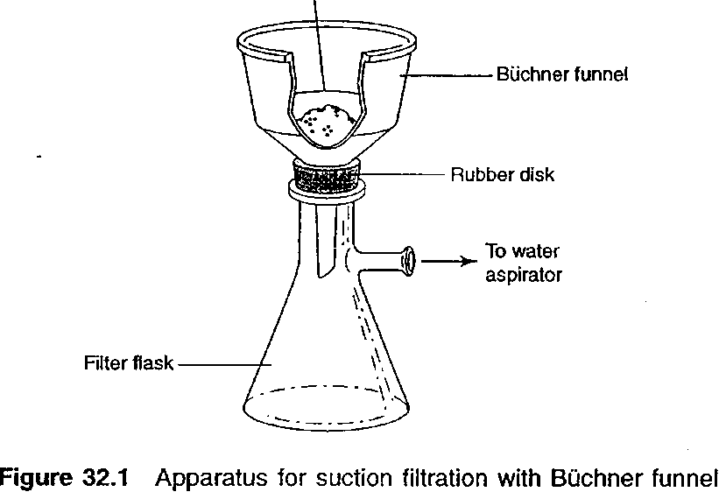
- Wash the soap with two 10-mL portions of cold water. Pull air through the product to dry it further. Place the soap curds on a watch glass or in a small beaker and dry the soap for 5-10 minutes. Use disposable, plastic gloves to handle the soap. Handle with care: The soap may still contain NaOH, which can irritate the skin. Save the soap you prepared for the next part of this experiment. Describe the appearance of the soap on your data sheet.
- Properties of Soaps & Detergents

Materials: Test tubes, stoppers to fit, droppers, small beakers, 50- or 100-mL graduated cylinder, stirring rod, laboratory-prepared soap (from part A), commercial soap product, detergent, pH paper, oil, 1% CaCl₂, 1% MgCl₂, and 1% FeC1₃
Prepare solutions of the soap you made in part A, a commercial soap, and a detergent by dissolving 1 g of each in 50 mL of distilled water. If the soap is a liquid, use 20 drops. ( All 3 solutions will contain 50 ml distilled water only the amount of soap/detergent will vary depending on their solid/liquid state: 1g solid soap/detergent or 20 drops liquid detergent ).
1. pH test Place 10 mL of each soap solution in separate test tubes. Use 10 mL of water as a comparison. Label. Dip a stirring rod into each solution, then touch the stirring rod to pH paper. Determine the pH. Record your observations in the Data Sheet. Save the tubes for the next step.
2. Foam test Stopper each of the tubes from step1 and shake for 10 seconds. The soap should form a layer of suds or foam. Record your observations in the Data Sheet. Save the tubes for next step.
3. Reaction with oil Add 5 drops of oil to each test tube from step 2. Stopper and shake each one for 10 seconds. Compare the sudsy layer in each test tube to the sudsy layers in step 2. Record your observations in the Data Sheet.
4. Hard water test Place 5 mL, of the soap solutions in three separate test tubes. Add 20 drops of 1% CaCl₂ to the first sample, 20 drops of 1% MgCl₂ to the second tube, and 20 drops of 1% FeC1₃ to the third tube. Stopper each test tube and shake 10 seconds. Compare the foamy layer in each of the test tubes to the sudsy layer obtained in part A step 2. Record your observations in the Data Sheet.

Data Sheet: Soaps and Detergents
A. Saponification: Preparation of Soap
1. Describe the appearance of your soap.

2. How would soaps made from vegetable oils differ from soaps made from animal fat?
( Hint: Think about appearance/texture and fatty acids composition )

3. How does soap remove an oil spot?

B. Properties of Soaps and Detergents
Tests | Water | Lab made soap | Commercial Soap | Detergent
pH
Foam
Oil
CaC1₂
MgCl₂
FeC1₃

Pre-Lab: Soaps and Detergents

- What happens when a fatty acid is reacted with NaOH? (Show the general reaction and explain.)

2. Why is ethanol added to the reaction mixture of fat and base in the making of soap?

3. Why is the product of saponification a salt?

