CHEM 132 Lab #3

Polymers – Macromolecules
Background
Polymers are high molar mass compounds, many of which have molar masses exceeding one million. Thus polymers are often referred to as macromolecules (very large molecules).
The process of forming very large, high molar mass molecules from smaller units is called polymerization. The large molecule is called the polymer, and the small unit, the monomer. The monomers may be alike or they may be different. When there are two or more different monomers, the macromolecule is known as a copolymer.
Starch, glycogen, cellulose, and proteins are examples of naturally occurring polymers. Cellulose and starch are polymers of glucose (a monosaccharide) found in plants. Silk and wool as well as the enzymes in our cells, are proteins polymers composed of amino acids. In the last century, scientists have developed many kinds of synthetic polymers that are important in our daily lives. Man-made polymers include parts of buildings, automobiles, machinery, toys, appliances, the nonstick coating on cooking sheets and pans, foam rubber, disposable diapers, plastic cups, garden hoses, outdoor clothing and carpeting, plastic wrap, computer disks, surfboards, etc. Examples of these are polyethylene, Nylon, Dacron, Bakelite, Lucite, polyvinyl chloride, etc.
Polymers that soften on heating, and therefore can be changed into different usable shapes, are known as thermoplastic polymers. Polymers that set to infusible solids and do not soften on reheating are known as thermosetting polymers.
All polymers may be classified as either addition polymers or condensation polymers. An addition polymer is one that is formed by the successive addition of repeating monomer molecules. A condensation polymer is one that is formed from monomers with the elimination of water or some other simple substance.
In the experiment, you will prepare two addition polymers, Plexiglas (polymethyl methacrylate) and Polystyrene and a condensation polymer, Nylon 6-10 (a polyamide).
A. Polystyrene
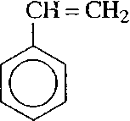
Styrene is the compound that is polymerized to give polystyrene.

Polystyrene is a clear, brittle plastic used to make plastic glasses and coffee cups. In the polystyrene polymer, there may be as many as 3000 styrene monomers. At high temperatures, the polymerization of styrene is spontaneous, but at lower temperature an initiator such as benzoyl peroxide, which forms a high-energy radical, is required. You may be familiar with the compound benzoyl peroxide, which is used in many skincare creams for treatment of acne. Since the initiators are unstable compounds, care should be taken not to keep them near flames or heat them directly. If a bottle containing a peroxide initiator is dropped, a minor explosion can even occur.
To prevent spontaneous polymerization of styrene in the bottle on a shelf, the manufacturer adds a small amount of an inhibitor, which is 4-tert-butylcatechol. This inhibitor is removed by passing styrene through some alumina, which absorbs the inhibitor.
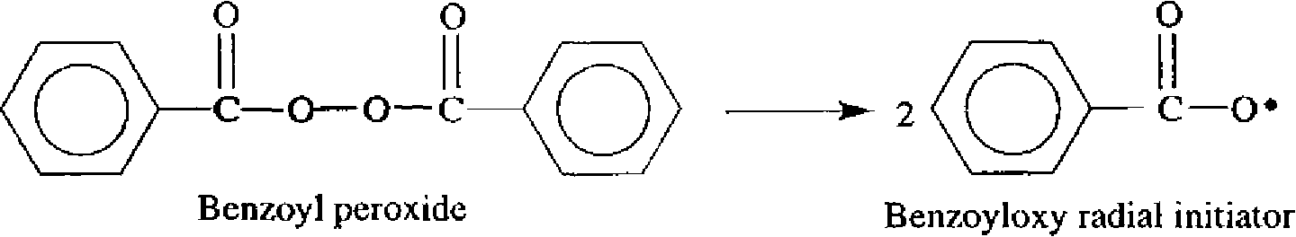
Please note the distinction between the monomer and the repeating unit. The monomer is the starting material and the repeating unit is part of the polymer chain. Chemically they are not identical. In the case of styrene, the monomer contains a double bond, while the repeating unit does not.

B. Nylon 6-10
Nylon was introduced in 1938, which makes it one of the first synthetic polymers. Polymers known as nylon are polyamides made by the condensation of diamines and dicarboxylic acids. Nylon 6-10 uses hexamethylene diamine and sebacic acid. Two numbers indicating the number of carbon atoms designate the different nylons, the first for the diamine and the second for the dicarboxylic acid. Thus in nylon 6-10 the diamine has 6 carbons, and the dicarboxylic acid has 10 carbons.

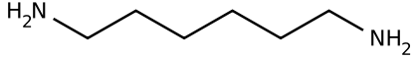

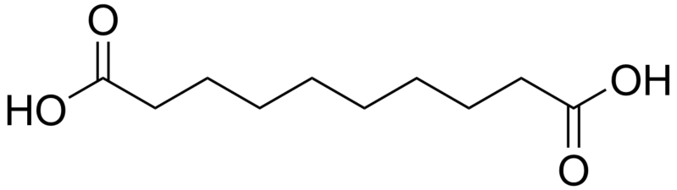
Hexamethylene diamine
+

Sebacic acid

In this experiment, sebacoyl chloride rather than sebacic acid is heated with the amine. The two reactants will be present in two layers. The polymer will form a film at the interface where the diamine and the diacid chloride are in contact.
C. Plexiglas
Plexiglas, also known as Lucite, is an addition polymer made from the monomer methyl methacrylate. Lucite is one of the polyacrylics, the monomers of which are derivatives of acrylic acid.
CH₂= CHCOOH CH₂ = C(CH₃) (COOCH₃)
Acrylic Acid Methyl Methacrylate
The polymerization of methyl methacrylate is a chain reaction catalyzed by benzoyl peroxide. The overall reaction is represented by this equation:
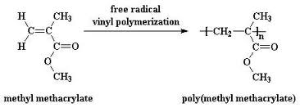
CH₂=C(CH₃)-COOCH₃ [-CH₂-C(CH₃) (COOCH₃)-]_{n}
Polyacrylics are clear, colorless polymers. They take a high polish, are transparent to visible and ultraviolet light, and have excellent optical properties. Lucite is used for windshields in airplanes, for contact lenses, automobile finishes, molded ornamental objects, etc.

Procedure
- Synthesis of Polystyrene
Materials: Styrene, benzoyl peroxide (or an acne preparation which contains 5% or 10% benzoyl peroxide), stirring rods, alumina, funnel, filter paper, hot plate, heavy-duty aluminum foil, 10- or 20-mL beaker, 50-mL beaker, wood stick
- Place 0.3-0.4 g of alumina in a test tube. Carefully add 4 mL of styrene, which contains inhibitor.
- Fold a filter paper. Pour the styrene-alumina mixture into the filter paper and collect the styrene (inhibitor removed) in a small beaker. Place used alumina in a nonhazardous waste container.
- Obtain two square sheets of aluminum foil 10 cm x 10 cm. Using a double layer of the aluminum sheets, form a mold by molding them around the bottom of a small beaker. Place this mold in a 50-mL beaker.
- Prepare a boiling water bath using a hot plate.
- Weigh out 0.050 g of benzoyl peroxide (or 0.2 g of a 10% benzoyl peroxide acne cream preparation) and add to the styrene (filtered). Swirl the beaker 3-4 minutes. Pour the mixture into the aluminum foil mold in the 50-mL beaker. Clamp the beaker containing the foil mold and styrene mixture to the ring stand. Lower the bottom of the beaker into the boiling water bath. Be careful not to spill the styrene mixture out of the foil mold as you set this up.
Leave the beaker in the boiling water bath for about 45 minutes. Add more water to the water bath as needed. Occasionally stir the styrene with a wooden stick. As the temperature rises, the mixture should become more viscous.
During this heating time, proceed to the synthesis of nylon 6-10.
6. Remove the beaker and the aluminum mold with the styrene product from the water bath, and allow it to cool slowly to room temperature. Then place the beaker in an ice bath for 20 minutes. If you leave the wooden stick in the styrene, the styrene will solidify around it. Remove the foil mold from the beaker, and separate the aluminum foil from around the polystyrene. You may need to let the polymer harden until the next laboratory time.
Describe the appearance and texture of the polystyrene product.

- Synthesis of Nylon 6-10
Caution: Use a fume hood. The reactants are irritating to the skin and eyes. Use gloves.
Hexamethylenediamine and sebacoyl chloride are irritating to the skin, eyes, and respiratory system. Sodium hydroxide is extremely caustic and can cause severe burns. Contact with the skin and eyes must be prevented. Hexane is extremely flammable. Hexane vapor can irritate the respiratory tract and, in high concentrations, be narcotic.

Materials: 50-mL, 100-mL, and 250 beakers, 10-mL and 50-mL graduated cylinders, forceps, metal spatula, large test tube (for spooling the nylon), stirring rods, gloves (must not dissolve in hexane), 50% aqueous ethanol solution, 6 M HCl, 6 M NaOH

Solution 1: 4% hexamethylenediamine ( NH₂-(CH₂)₆-NH₂ in NaOH )
If solid, place the reagent bottle in hot water to melt (mp 39°C).
Solution 2: 4% sebacoyl chloride ( ClCO(CH₂)₈COCl in hexane )
- Obtain a clean 20-mL vial. Add first to this vial 10 mL of solution 1 (4%hexamethylenediamine in NaOH).
- Tilt the vial containing the hexamethylenediamine solution 1 and slowly pour the 10 mL sebacoyl chloride solution 2 down the wall of the vial. Allow the mixture to sit undisturbed for 1 minute. Two layers will form with a whitish film of nylon polymer film at the interface. Run a metal spatula around the walls of the vial to loosen the film from the vial sides.
- Carefully lower the tip of a pair of forceps through the top layer to take hold of the center of the nylon film. Slowly pull a strand of the polymer upward out of the solution. A continuous section of nylon should form. Secure the end of the strand in the forceps by wrapping it around the center of the large test tube. Holding the test tube, turn it slowly to draw out a continuous nylon strand from the interface. You should be able to draw out most of the interface film. If the strand breaks, use forceps to start a new one. Rinse the nylon strand on the test tube under tap water to remove excess reactants. Do not touch the nylon strand before you have thoroughly washed it with water.
- Use a metal spatula to detach the nylon loop from the test tube and slide the nylon loop into a beaker containing 10 mL of 50% aqueous alcohol solution to remove any remaining reactants. Rinse with water again. Using forceps grab an end of the nylon and stretch out the nylon strand and place it on paper towels until it is dry.

- Describe the appearance and texture of the nylon polymer.

- Cut a 15-20 cm section of nylon and pull on both ends. When you stretch the nylon, does it break or return to its original form (elastic)? Record your observations.
- Cut three 2-3 cm long sections of nylon. Place one piece in a test tube containing 5 mL of 6M HC1. Place a second piece in a test tube containing 5 mL of 6M NaOH. Place a third piece in a test tube containing 5 mL of acetone.
- Observe any changes in the nylon in the presence of a strong acid, a strong base, and an organic solvent. Record your observations.
Disposal
Stir the remaining reaction mixture to form a ball of nylon and discard in the proper solid waste container. Use a metal spatula to remove any remaining nylon polymer from the glass. Place remaining solvents in the proper waste liquid container.

C. Synthesis of Polymethyl Methacrylate (Plexiglas)
Materials: methyl methacrylate, benzoyl peroxide (catalyst), 10 ml graduated cylinder, test tubes, 100-200 ml beaker
- Measure 5 mL of methyl methacrylate from the reagent bottle into a clean, dry test tube (find 5 mL mark on a test tube).
- Add about 0.025 g of the catalyst (benzoyl peroxide) to the methyl methacrylate.
- Dissolve the benzoyl peroxide by swirling the mixture.
- Place the test tube in a beaker of gently boiling water. The volume of water in the beaker should be such that about one-half of the content of the test tube is submerged in the water. Watch the tube closely, and when gas bubbles start to form (5 to 10 minutes) remove the tube from the water and place it in the test tube rack. Continue to observe the tube as the polymerization proceeds to form a hard, glass-like polymer.
- While the polymerization is occurring, carefully feel the test tube to determine if the reaction is exothermic or endothermic.

Data Sheet: Polymers
Fill in the table with your observations regarding: appearance/texture, stretching, exothermic/endothermic reaction, reaction with HCl, NaOH and acetone.
 | Appearance/  Texture | Stretching | Exo/ Endo | HCl | NaOH | Acetone
Polystyrene

Nylon 6-10

Plexiglas

Questions:
- Which polymer was the most chemically reactive? Explain based on your results.

- Rank the polymers from most endothermic to most exothermic, based on your results.

Pre-lab: Polymers

- Why should you not expose t-butyl peroxide to direct heat?

- Write the reactions for the polymerization of:
a. vinyl chloride (chloroethene)

b. Cl—CO—(CH₂)₃—CO—Cl with H₂N—(CH₂)₄—NH₂.

Show the repeating units of the resulting 2 polymers (Polyvinyl chloride - PVC and polyamide).

