CHEM 489 Advanced Environmental Chemistry – Spring 2020

Worksheet #3: Green & Sustainable Chemistry (10 points)
Due: Tuesday, February 18 at 9:30 AM (not accepted late)

Journal Club #4: Your topic is “Connecting Systems Thinking to Green & Sustainable Chemistry”.
You can select one of the SDG articles I placed on the class website, or find your own article.
Due - Tuesday, February 18, you need to send me an email identifying the article you selected or found.
Due - Thursday, February 20 you will give a 5 minute, informal presentation on your article, focusing on connecting Systems Thinking to Green & Sustainable Chemistry.

Don’t get bogged down reading these articles! Focus on three of the following: (1) defining new and relevant terms, (2) importance, (3) the application, and (4) Broader implications either within or outside of the chemistry enterprise.

Writing Prompt #4 - What is green and sustainable chemistry? Update your document by including the connection between green chemistry and the UN SDGs. You must include one relevant reference. You do NOT need to send me your updated document, but will be responsible for including this prompt in your final paper.

Worksheet #3: Green Chemistry, Sustainable Development and the UN SDGs.
Due - Tuesday, February 18

To answer the questions on this worksheet you will need tables of the UN SDGs and the 12 Principles of Green Chemistry. Both of these can be found on the class web page. You should also review your lecture notes from Tuesday, February 11. This material is also on the class website: http://webhost.bridgew.edu/ebrush/CHEM%20489.HTM. You can type your answers directly on this document. You can work together, but must submit your own worksheet and your own answers.

(1) Green Chemistry and Sustainable Development. Sustainable development touches many aspects of human health and the environment. Adopted by world leaders in September 2015 at an historic UN Summit, the 17 Sustainable Development Goals of the 2030 Agenda for Sustainable Development officially came into force. Over the next ten years, countries will mobilize efforts to end all forms of poverty, fight inequalities and tackle climate change, while ensuring that no one is left behind

Chemistry has been challenged to help move forward the 2030 Agenda for Sustainable Development. This calls for innovation in the development of new technologies, and support for the creativity and innovation of scientists guided by the Principles of Green Chemistry. One of the key principles of green chemistry is the design of chemical products and processes that maximize the incorporation of raw materials in forming products, while minimizing the production of waste.

We discussed the following definitions in class. Use these definitions to answer the following questions.

Definitions for Green Chemistry.
Technical. Green Chemistry aims to reduce or eliminate the use and generation of hazardous substances associated with the design, manufacture, and use of chemicals.

Molecular Design. Green chemistry is an approach to chemistry that aims to maximize efficiency and minimize hazardous effects on human health and the environment. This can be accomplished by implementing the 12 Principles of Green Chemistry.

Risk Assessment. Risk = Hazard x Exposure x Vulnerability

Definition for Sustainable Development. Meeting the Economic, Environmental and Social needs of the present without compromising the ability of future generations to meet their own needs (People, Prosperity, Planet).
(a) In the production of a consumer product, sustainable chemistry often refers to the product itself, while green chemistry refers to the production process. Explain what this statement means.

(b) Explain why using reactions with high atom economy is important for sustainable development.

(c) What is the metric of Process Mass Intensity (PMI)? Why is the PMI a good yardstick to drive sustainable processes in the pharmaceutical industry? For reference, use the chart below.
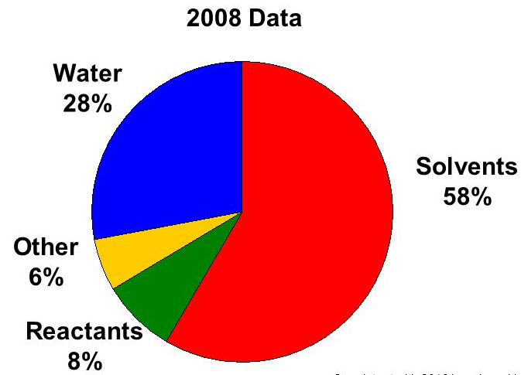

Chart A. Percentage of chemical waste in the pharmaceutical industry.

(2) Green Chemistry and the Sustainable Development Goals Applied to Ionic Liquids. Room temperature ionic liquids refers to organic salts that are a new class of environmentally friendly alternative solvents. A general example of an imidazolium-based ionic liquid is shown below:

Ionic liquids have the following beneficial characteristics as compared to traditional organic solvents:
- Immeasurably low vapor pressure (non-volatile)
- Non-flammable
- Boiling points in excess of 300ºC
- Polar and non-polar
- Can be recycled and reused

To answer this question, you will need tables of the UN SDGs and the 12 Principles of Green Chemistry. Both of these can be found on the class web page.

The chart at the right proposes connections between the central topic of ionic liquid technology, the UN SDGs (SDG), and Green Chemistry Principles (GCP).

(a) Justify each connection to the central topic.

(b) If you disagree with a connection, explain why, suggest an alternative, and explain your alternate choice.

